Matlab auditory periphery (MAP)
Model technical description
Ray Meddis, Department of Psychology, University of Essex, UK
rmeddis@essex.ac.uk

1 October 2011

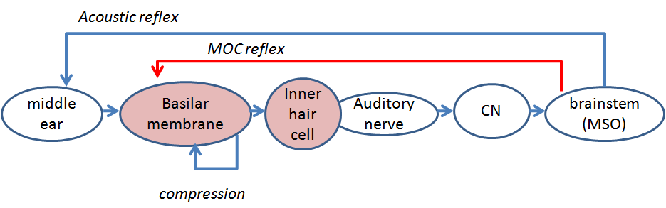
Figure 1. Schematic of the MAP computational auditory model

The computational model of the auditory periphery is slowly evolving and improving. This account represents the model as it is currently used in our laboratory. The current implementation of the MATLAB Auditory Periphery model is called MAP1_14. The program that realizes these equations and procedures can be found in the MAP1_14 software package for which a manual is available.

The most recent published detailed account is Meddis (2006). However, the model has evolved considerably since then. The most notable additions concern the acoustic reflex and the medial olivo cochlear effects. These are explained below.

The original model was velocity based, while the new model uses displacement. The advantage of displacement formulations over velocity is that the model works well using the same value for many parameters at all locations along the basilar membrane. The earlier velocity formulation required different values for each location. This results in a considerable simplification of the parameter structure in the model and offers new conceptual insights.

The most authoritative source of parameters for normal hearing can be found in the MAP1_14\MAPparameters\MAPparamsNormal file in the MAP1_14 software package.

Parameters from the MAPparamsNormal file are shown in this style.

The current values in the file should be taken as superseding any values given below. This document is not automatically updated when the parameters are changed. All parameter and measurement units are international units (meters, seconds, volts, etc.).
The model consists of a cascade of stages:
- Outer middle ear
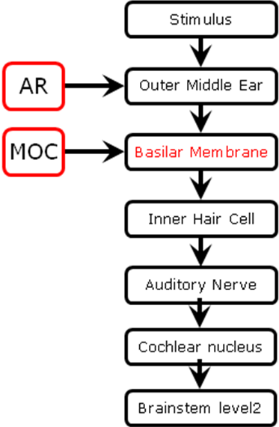
- Basilar membrane
- Inner hair cell (dual resonance nonlinear, DRNL)
  - Stereocilia
  - Receptor potential
  - Synaptic calcium influx
- Auditory nerve/IHC synapse
- Refractory Effect
- Cochlear nucleus sustained chopper (CS) cells
- Brainstem level 2 neurons (can be MSO or IC cells)

The computational formulae of each of the stages are described in sequence below.

Stimulus
The input to the model is a single-channel (mono) acoustic pressure waveform expressed in Pascals sampled at dt spacing where dt=1/sampleRate.

MAP cannot handle two-channel stereo signals at present.

Outer middle ear (OME) filtering
The method for simulating the OME activity is a departure from earlier published methods which were based on stapes velocity cadaver measurements. The current version uses stapes displacement measurements made in live-human measurements.

External resonance is modeled as a bandpass filter with sound pressure as the input and output. A gain of 10 dB is applied to the output of a 1st -order Butterworth filter with a lower cut-off of 1000 Hz and an upper cut-off of 4000 Hz. This is represented in the MAPparamsNormal as
OMEParams.externalResonanceFilters= [10 1 1000 4000];

The waveform is converted from pressure (Pa) to tympanic membrane (TM) displacement (m) by applying a 1str order low-pass filter (cut-off 50 Hz) and a scalar (45e-9 m/Pa.).
OMEParams.stapesScalar=45e-9;

The reduced response of the stapes at low frequencies is modeled by applying a high-pass filter to the TM displacement. This is a 1st- order, low pass Butterworth filter with cut-off frequency of 1000 Hz. These parameters were chosen to model the intra-operative, human stapes velocity data of Huber et al. (2001).
OMEParams.OMEstapesHPcutoff= 1000;

Acoustic reflex (AR)
The stapes displacement is subject to a variable attenuation scalar, AR_{t} , derived below on the basis of the brainstem response modeled as a negative feedback loop. This is described below in the Acoustic reflex section.

Evaluation
The resulting stapes displacement as a function of frequency can be evaluated using the testOME program in the MAP1_14\testPrograms folder. This charts the external ear filter response as a function of frequency. It also charts the stapes displacement as a function of stimulus frequency and compares it with intra-operative live-human data of Huber et al. (2001).

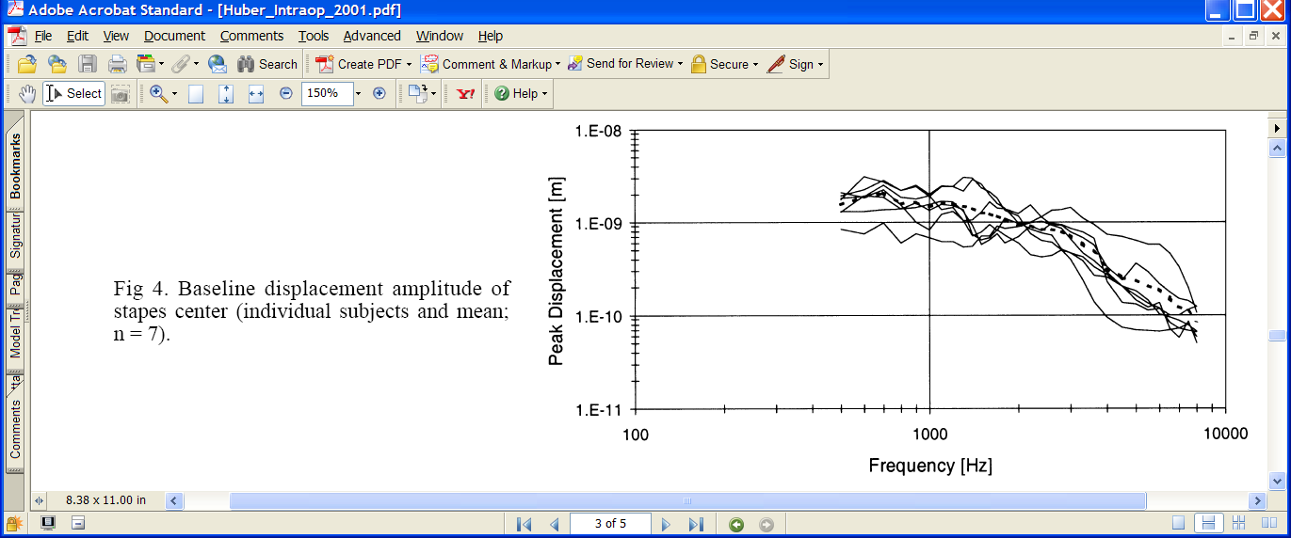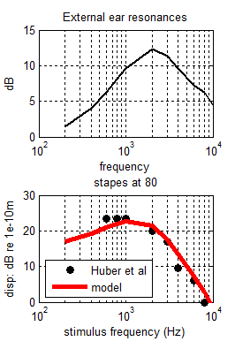
Figure 2. Top: Model external resonance. Bottom: stapes displacement comparison of model output with data from Huber et al. 2001

Basilar membrane mechanical filtering: DRNL filter
The filtering of the BM is modeled with a ‘Dual-Resonance-Non-Linear’ (DRNL) filter architecture that has been described and evaluated more fully elsewhere (Meddis et. al., 2001; Lopez-Poveda and Meddis, 2001; Sumner et al., 2003b). The input is stapes displacement, x(t).

The BM is modeled as a number of discrete locations each identified by its best frequency (BF). The BFs of these locations are normally equally spaced on a log scale between two values. For example,
lowestBF=250; highestBF= 8000; numChannels=21;
BFlist=round(logspace(log10(lowestBF),log10(highestBF),numChannels));

The DRNL filter consists of two parallel pathways, one linear and the other non-linear. Their outputs are summed to produce an output representing the displacement of the cochlear partition.

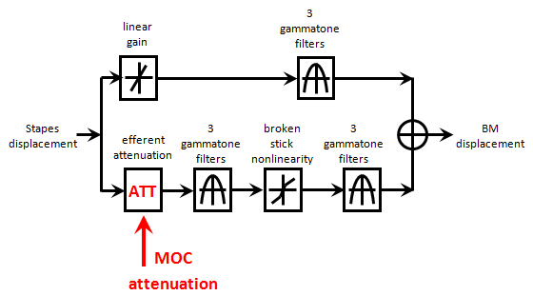

Figure 3. Schematic of the DRNL simulation of BM displacement at a single location. The upper path is the ‘linear pathway’. The lower path is the ‘nonlinear pathway’.

Nonlinear pathway
The nonlinear pathway consists of the following cascaded sequence;
1) 3 identical first-order gammatone filters,
2) a broken-stick compression function,
3) 3 identical gammatone filters.

Centre frequencies. All filters in the path have the same center frequency, CF_{Nl} , equal to the BF of the location.

Bandwidth. All gammatone filters in the nonlinear pathway at a specific location on the BM have the same bandwidth, nlBW. However, bandwidths increase with BF and are computed using the empirical equation
p=0.2895, q=250 , nlBW(BF)= p * BF+ q

Compression. The broken-stick compression function is linear up to a displacement known as the compression threshold (ctBM).
h_{t}=a x_{t} , |x_{t}| <= ctBM
DRNLParams.a=5e4;

When the displacement is greater than ctBM, the portion of the waveform greater than the displacement threshold is compressed. This rule is applied to both positive and negative halves of the waveform.
h_{t} = SIGN(x_{t}) ctBM + SIGN(x_{t}) b(|x_{t}|-ctBM)^{c}, |xt|>ctBM
DRNLParams.c=0.2;

CtBM is the same value at all locations. It is a scalar displacement (m) but, for convenience, the compression threshold is specified as dB above a reference value of 10e-9 m, a value that is close to threshold for normal hearing.
DRNLParams.CtBMdB = 10; and CtBM=10e-9*10^(CtBMdB/20);

where a, CtBM and c are defined immediately above and are parameters that are invariant along the cochlear partition.

Linear pathway
The linear pathway consists of the following cascaded sequence;
1) a scalar, g, representing gain or attenuation
2) a cascade of 3 identical gammatone filters

DRNLParams.g=50;
DRNLParams.linOrder=3;

The CF (linCF) and bandwidth (linBW)of the gammatone filter are specific to the location along the cochlear partition . The CF of the linear pathway is not the same as the CF of the linear pathway and is computed using the following empirical equation
p=153.13, q=0.7341, linCF(BF) = p + q*BF

The bandwidths of the linear filters are computed
p=100, q=0.6531; linBW(BF)= p + q*BF;

BM output
The outputs of the two pathways are summed to give the displacements of the individual locations. Note that the phase characteristics of the two pathways are different and this summation may give rise to phase cancellation.

This output displacement is subject to attenuation by medial olivo-cochlear efferent activity. This attenuation is linear and is computed below in the brainstem section (MOC).

Evaluation
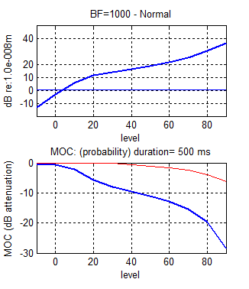
Figure 4. Top: Basilar membrane input/output function at 1 kHz. Bottom MOC and AR attenuation.

The resulting BM displacement as a function of level can be evaluated using the testBM program in the MAP1_14\testPrograms folder.

IHC apical transduction
The BM displacement, v(t), is viscously coupled to the inner hair cell stereocilia displacement, u(t).

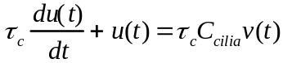
where C_{cilia} is an attenuation factor (scalar) and τ_{c} is a time constant
IHC_cilia_RPParams.tc= 0.0003;
IHC_cilia_RPParams.C= 0.03;

The cilia displacement determines the apical conductance G(u). The total apical conductance is given by:
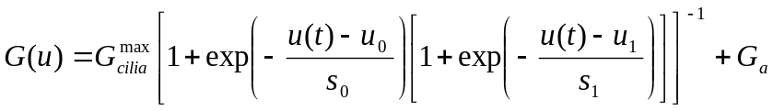
where G_{cilia}^{max} is the transduction conductance with all channels open, G0 is the resting conductance and G_{a} is the passive conductance in the apical membrane. s₀, u₀, s₁ and u₁ are constants determining the exact shape of the non-linearity.
IHC_cilia_RPParams.Gmax= 6e-9;
IHC_cilia_RPParams.Ga= .8e-9;
IHC_cilia_RPParams.u0= 5e-9;
IHC_cilia_RPParams.s0= 30e-9;
IHC_cilia_RPParams.u1= 1e-9;
IHC_cilia_RPParams.s1= 1e-9;

IHC receptor potential
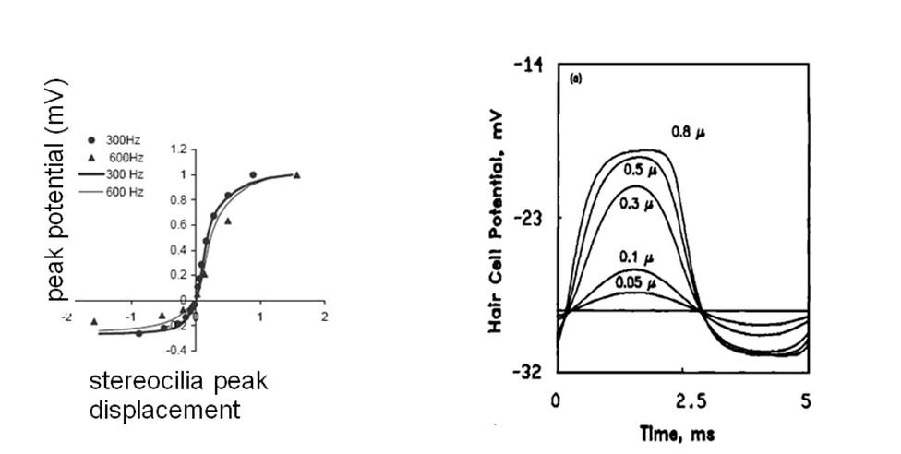

The membrane potential, Vt, of the cell body is modeled with a passive electrical circuit analog:

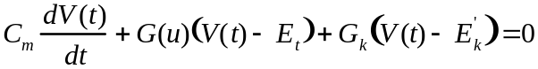

where C_{m} is the cell capacitance; G_{k} is the voltage-invariant basolateral membrane conductance; E_{t} is the endocochlear potential; and E_{k}’=E_{k} + E_{t}R_{pc}is the reversal potential of the basal current E_{k} corrected for the resistance, R_{pc}, of the supporting cells.
IHC_cilia_RPParams.Cab= 4e-012;
IHC_cilia_RPParams.Et= 0.100;
IHC_cilia_RPParams.Gk= 2e-008;
IHC_cilia_RPParams.Ek= -0.08;
IHC_cilia_RPParams.Rpc= 0.04; % combined resistances

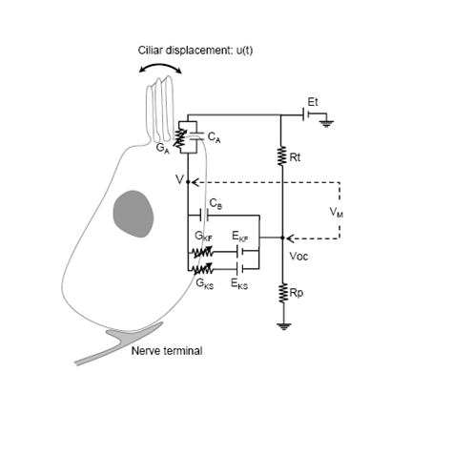

Evaluation
The IHC response as a function of level can be evaluated using the testRP program in the MAP1_14\testPrograms folder.

Signal frequency: 800 Hz | Signal frequency: 7000 Hz
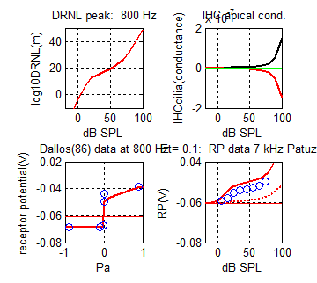 | 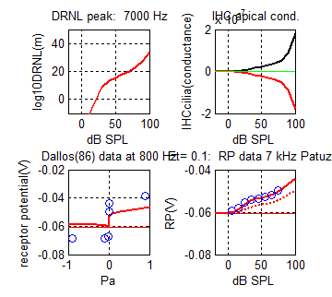
Figure 5. Receptor potential evaluation at two signal frequencies A:800 Hz and B:7000 Hz). (In each figure) Top left: DRNL input/output function. Top right: Apical conductance (Gu). Bottom left: peak and trough receptor potential at different signal levels compared with equivalent 800 Hz data from Dallos 1986. Bottom right: peak receptor potential input/ output function compared with 7 kHz data from Patuzzi and Sellick.

Pre-synaptic calcium controlled transmitter release function

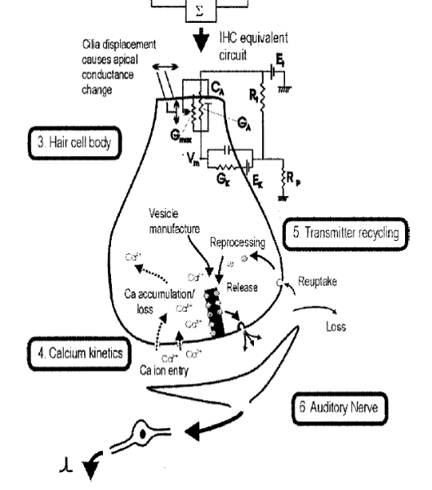

The Calcium current, Ica, is determined by the membrane potential,
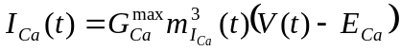

where E_{Ca} is the reversal potential for calcium and G_{Ca}^{max} is the calcium conductance in the vicinity of the synapse, with all the channels open.
IHCpreSynapseParams.GmaxCa= 14e-9;
IHCpreSynapseParams.ECa= 0.066;

m_{Ica}(t) is the fraction of calcium channels that are open. Its steady state value, m_{Ica,∞}, is modelled by a Boltzmann function,
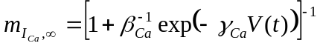

where γ_{Ca} and β_{Ca} are constants chosen to reflect published observations of calcium currents
IHCpreSynapseParams.beta= 400;
IHCpreSynapseParams.gamma= 100;

m_{Ica}(t) is a low pass filtered function of m_{Ica,∞}
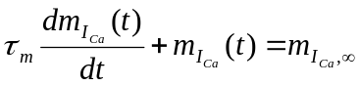

where τ_{m} is a calcium current time constant.
IHCpreSynapseParams.tauM= 0.00005;

Pre-synaptic calcium concentration [Ca²⁺](t) is modelled as a first-order low-pass filtered function of calcium current, I_{Ca}(t)
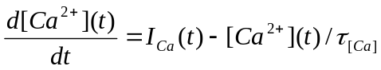

where τ_{Ca} is a time constant reflecting the dwell time of pre-synaptic calcium in the vicinity of the synapse. The value of τ_{Ca} varies according to the desired spontaneous rate (see below).

The probability of the release of a transmitter vesicle is proportional to the cube of [Ca²⁺] concentration:
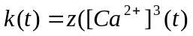)

where z is a scalar for converting calcium levels into release rate
IHCpreSynapseParams.z= 2e42;

τ_{Ca} controls the rate at which calcium is cleared from the region adjacent to the synapse. As a consequence it determines the release characteristics of the synapse. Low values for τ_{Ca} result in low spontaneous (LSR) synapses. HSR synapses can be modelled using higher values for τ_{Ca}. The software allows for HSR and LSR synapses to operate in parallel.

LSRtauCa=40e-6; HSRtauCa=80e-6;
IHCpreSynapseParams.tauCa= [LSRtauCa HSRtauCa];

Evaluation
Currently, there are no programs to evaluate these equations.

Quantal and probabilistic model of synaptic adaptation
More detailed accounts of transmitter release in a probabilistic form can be found in Meddis (1986, 1988) and Hewitt and Meddis (1991) and Sumner (2002, 2003a and 2003b). A description of the quantal version is found in Sumner (2002).

Individual vesicles of neurotransmitter (glutamate), are released from an immediate pre-synaptic (q) store into the cleft (c), at a rate, k(t), that is dependent on calcium concentration.

In the cleft, the transmitter disperses and some is lost from the system at a rate l. The remaining transmitter in the cleft is taken back into the cell into a reprocessing store (w) at a rate r. Here it is repackaged into vesicles that are returned to the immediate store at a rate x.

Additionally, q is continuously replenished with new transmitter vesicles at a rate, y[M-q(t)] where M represents the maximum number of transmitter quanta that can be held in the immediate store.
AN_IHCsynapseParams.M= 12;
AN_IHCsynapseParams.y= 6;
AN_IHCsynapseParams.x= 60;
AN_IHCsynapseParams.l= 250;
AN_IHCsynapseParams.r= 500;
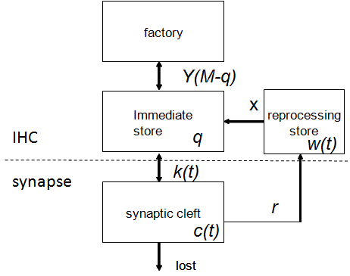
Figure 6, Flow diagram for transmitter vesicles across the synaptic cleft and back into the cell

Probability computations
For the probability model, the transmitter substance can be treated as a continuous substance and the quantities tracked as follows

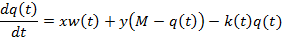

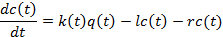

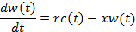

Quantal computations
A more realistic model treats transmitter substance as quantal, i.e. as a small integer value.
Neurotransmitter in the immediate store is quantal, and enters and leaves the immediate store stochastically. The stochastic transport of neurotransmitter is described by the function N(n,ρ), in which each of n quanta has an equal probability of release, ρ.dt, in a single simulation epoch. In the cleft and reprocessing stores, transmitter is a continuous quantity. This means, for instance, that the contents of the reprocessing store must contain at least enough transmitter to create one vesicle before a quantum can re-join the immediate store. The output from the synapse into the cleft is a stream of discrete events indicating vesicle releases, N(q(t),k(t)).
The following simultaneous equations represent the flow of transmitter through the system.

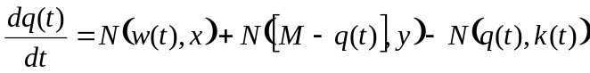
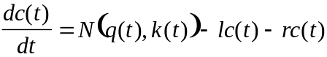
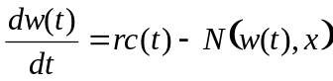

Initial values for the variable quantities are found as follows (Meddis Hewitt and Shackleton, 1990):
c₀= k₀ym/(y(l+r)+k₀l) , q₀= c₀(l+r)/k₀ , w₀=c₀r/x

Where k0 is the resting value of k(t) found by evaluating k(t) for u(t)=0 in the previous section.

The evaluation of the movement of transmitter substance is computationally intensive. To ease this burden, the evaluation is normally carried out at a lower sample rate (around 10 kHz) by down-sampling k(t) by a speed-up factor.
AN_IHCsynapseParams.ANspeedUpFactor=5

If more than one type of synapse (e.g. HSR, LSR) is modeled (by employing more than one value for τ_{Ca}), independent parallel streams of AN fibers are computed.

Evaluation
The resulting of available transmitter as a function of level can be evaluated using the testsynapse program in the MAP1_14\testPrograms folder.

The responses of the AN fibers can be visualized using the testANprob function in the MAP1_14\testPrograms folder. This shows the rate/level function for both onset and adapted rates and for both HSR and LSR fibers.

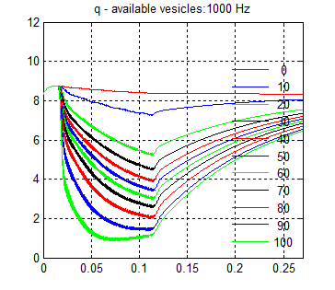 | 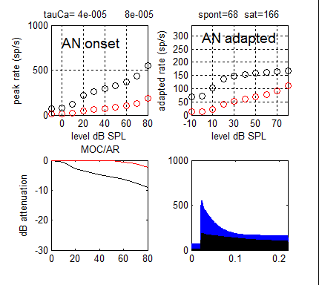
Figure 7. Tracks of amount of available (pre-synaptic) transmitter during and following the presentation of a 100 ms tone at a range of levels (dB SPL) | Figure 8. AN response (spiking probability) for HSR (black circles) and LSR (red circles) fibers in response to 200 ms tones at BF. Top left: onset rates. Top right: adapted rates. Bottom left: AR and MOC attenuations applied. Bottom right: PSTH for HSR (blue) and LSR (black).

Auditory nerve response

Probability
If the model is computed in probability mode, the firing rate is based on the quantity c(t), the amount of transmitter in the cleft

ANrate=c(t)/dt

Quantal
An action potential is generated in an auditory nerve whenever at least one vesicle is released into the synaptic cleft (i.e. if N(q(t),k(t)) ≥ 1) unless the fiber is refractory.
An absolute refractory period lasting 0.75 ms is applied; if one spike follows anoth within this period, the second one is ignored.
AN_IHCsynapseParams.refractory_period= 0.00075;

At the end of this period a release event is converted into a spike on a probabilistic basis as a function of time (s) since the last spike:

P_{conversion}= 1- exp(t/0.0006)

A large number of AN fibers (>50) are computed within each channel.
AN_IHCsynapseParams.numFibers= 100;

Brainstem single cell responses
Individual brain cell responses are modeled using MacGregor’s(1987) point neuron model. This model has the advantage of simplicity and rapid execution time while retaining a modicum of flexibility so that different kinds of cells can be represented. The account below covers only sustained chopper responses.

The input to the cell consists of streams of action potentials from for example AN spikes or other brainstem units. The output from the cell is a single stream of action potentials. Input and output spikes are modeled as Dirac pulses and represented as a stream of 0s and 1s. these are stored by the software as logical matrices.

A single-cell model consists of two stages: 1) input at the dendrites and 2) spike generation at the soma.

The dendritic input stage converts each input spike into an alpha function, α(t), to simulate a post synaptic potential

α(t) = I_{spike} .τ.t exp(-t/ τ) , (0 < t < 5 τ)

where I_{spike} is the current per spike, τ is a time constant based on the dendritic lowpass cutoff frequency (f)

τ = 1/(2πf).

This cutoff frequency is lower for synapses on remote dendrites. Synapses close to the soma have shorter, higher alpha functions. Sustained chopper neurons are modeled using synapses remote from the soma and have cutoff frequencies in the region of 50-100 Hz with corresponding time constants of 32-16 ms.

The alpha function is convolved with the (logical) array of the sum of all input spikes to generate the post-synaptic current, I_{t}. this assumes that all inputs are equi-distant from the soma.

The trans-membrane potential at the cell soma, E, is represented as a deviation from resting potential, Er, and tracked using the equation

dE(t)/dt = −E(t)/τ_{m}+I(t)R+Gk(t)[Ek–E(t)]

where τ_{m} is the membrane time constant of the cell, R is the cell membrane resistance, Ek is the potassium reversal potential relative to Er and Gk(t) is the cell potassium conductance

An action potential is initiated when the membrane potential exceeds a threshold E(t)>Th0. This threshold is fixed throughout for the chopper neuron model. The variable s is set to 1 for only a single epoch when an AP occurs, otherwise it is always 0.

Gk is tracked as follows

dGk(t)/dt = − Gk(t)/τGk + (b · s)

where τ_{Gk} is the potassium time constant, b is a step increase in Gk following an action potential indicated when s=1.

The base model uses the following arrangement of connections. A band of AN fibers (all from the same BF converge on a CN chopper cell. The output from a band of CN choppers converges on a single level-2 chopper unit. This second layer of cells can be thought of as IC units or as MSO units. The point is that they are outside of the cochlear nucleus. How we view this depends on the task in hand. For the model of efferent activity described below, it is convenient to think of the second layer as the MSO because the activity in these units is used to control the activity of the medial olivocochlear bundle. Alternatively we could think of it as a set of motor neurons controlling the acoustic reflex. When harnessed to multiThreshold for psychophysical evaluation of the model we might think of it as a unit in the inferior colliculus (IC) responsible for detecting the presence of any sound. Clearly, this model leaves considerable room for refinement but it gets the show on the road. The main thing is to view the level 2 unit flexibly as any higher-order function.

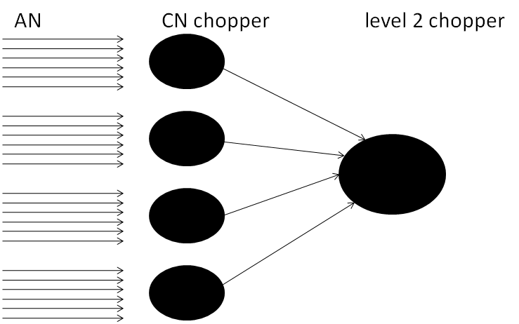

Figure 9. Schematic of neuronal circuitry in the MAP model (see text). The circuit for a single BF is shown. This will be replicated for each channel in the model.
Both CN and level two units use the MacGregor model but they have different parameters. To distinguish the parameters they are stored in structures with different names; MacGregorMulitParams for CN units and MacGregorParams for level2 units. They are also processed using different function code.

If more than one fiber type is used (e.g. HSR and LSR), this scheme is replicated independently for each type with no communication between the two sets of activity.
Previously there was only one level 2 neuron per BF; now there are two such neurons. In order to replicate the efferent system it is important to use both fiber types. The HSR fiber group controls the MOC while the LSR fiber group controls the AR. This is, of course, speculative at best but it is convenient that HSR fibers have low thresholds while LSR fibers have high thresholds. This agrees with the thresholds of the two types of efferent activity.

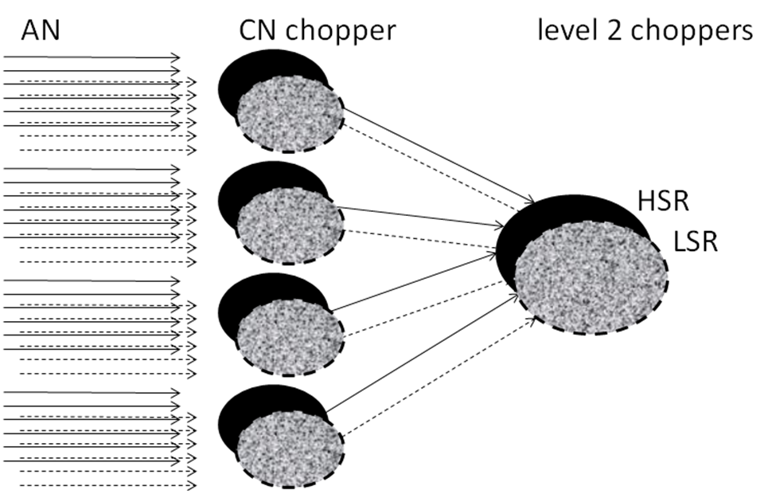

Figure 10. Same as previous figure except that the system is replicated for HSR and LSR fibers.

Cochlear nucleus units
Cochlear nucleus (CN) units are the first layer of brainstem cells in the model. A number of sustained units (typically 10) are computed within each BF channel.
MacGregorMultiParams.nNeuronsPerBF= 10;

Each unit receives a number of AN fiber inputs.
MacGregorMultiParams.fibersPerNeuron=10;

It may seem confusing to have the same number of input fibers per unit as the number of units; this is not obligatory. However, it has the advantage of keeping the parameters of the level 2 units similar to the CN units.

The input fibers are chosen at random (with replacement) from all available AN fibers in that channel. Typically, there will be 100 AN fibers available within each fiber type category.

The first stage of processing is the conversion of the input spikes to a dendritic current as explained above
MacGregorMultiParams.dendriteLPfreq=50;
MacGregorMultiParams.currentPerSpike=35e-9;

The parameters of the CN units are typically adjusted to have a low spontaneous rate (close to 10 spikes/s) and a sustained rate of approximately 200 spikes/s at high signal levels. Sustained chopper units should show steady, equally spaced spiking activity when adequately stimulated.
MacGregorMultiParams.Cap=1.67e-8;
MacGregorMultiParams.tauM=0.002;
MacGregorMultiParams.Ek=-0.01;
MacGregorMultiParams.dGkSpike=1.33e-4;
MacGregorMultiParams.tauGk= 0.0005;
MacGregorMultiParams.Th0= 0.01;

If independent sets of AN fibers have been modeled (e.g. HSR and LSR), independent streams of CN units will also be computed.

Brainstem level 2 units
The operation of these units are essentially the same as those for the CN units although they have different if similar parameters. The software works by taking the CN unit responses serially down the matrix so it is important that the fibersPerNeuron parameter is equal to the number of CN units available (in this case 10). The parameters of the level 2 units are adjusted so as to have a zero spontaneous rate but a threshold as close as possible to the AN rate/level threshold.

MacGregorParams.fibersPerNeuron=10;
MacGregorParams.dendriteLPfreq=100;
MacGregorParams.currentPerSpike=120e-9;
MacGregorParams.currentPerSpike=40e-9;
MacGregorParams.Cap=16.7e-9;
MacGregorParams.tauM=0.002;
MacGregorParams.Ek=-0.01;
MacGregorParams.dGkSpike=1.33e-4;
MacGregorParams.tauGk= 0.0012;
MacGregorParams.Th0= 0.01;

Evaluation
The responses of the CN and level 2 units can be visualized using the testAN function in the MAP1_14\testPrograms folder. This shows the rate/level function for both CN and level 2 neurons. Coefficient of variation statistics are given for AN and CV. Ideally this should be greater for AN than CN activity.

Table 8 MacGregor IC neuron parameters
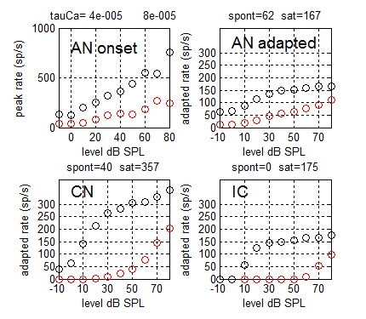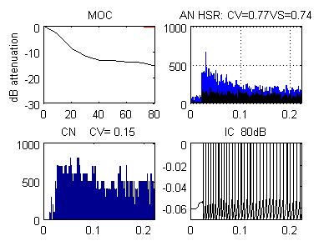
Figure 11. A: Rate/ level functions for auditory nerve fibers, first and second level brainstem units. Two streams are represented, HSR (black) and LSR (red). The tests are based on 200-ms tones at BF (=1 kHz). AN onset rate is based on spikes in the 1-ms bin with the most spikes. Other panels are adapted rates based on the final 100 ms. B: the last of a series of figures showing PSTHs for AN and CN spiking activity. The bottom right panel shows the spiking activity of the single level 2 chopper unit. It should show a regular firting pattern.

Efferent system

Acoustic reflex
This topic is under active development and the author should be consulted for the latest picture.

The acoustic reflex (AR) is an attenuation applied to the stapes displacement. The amount of attenuation is based on the single brainstem level 2 activity in the LSR stream. This is intended to represent MSO units that receive inputs from CN (chopper?) units receiving input from LSR AN fibers. The choice of LSR AN fibers as the source is simply to guarantee high thresholds.

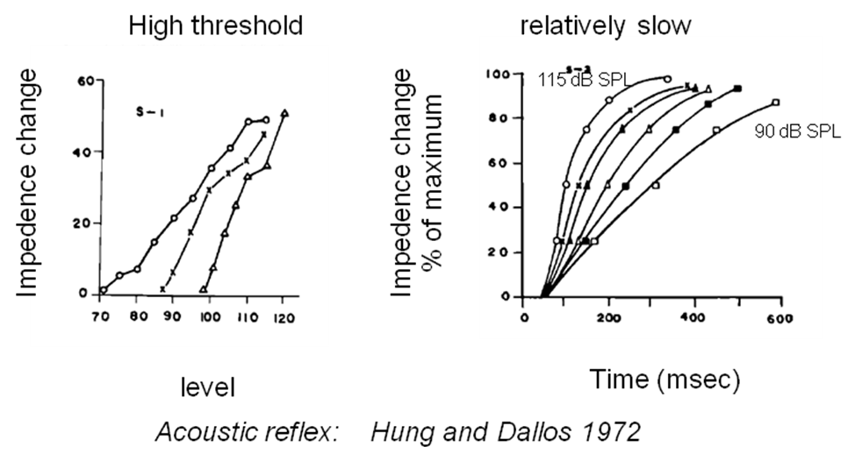
Figure 12. Hung and Dallos (1972). Left panel: input/output functions at the acoustic reflex. Open circles are wideband noise; crosses are 1 kHz and triangles are 600 Hz. Right panel: build up to maximum strength at a range of signal levels at 1 kHz.

The attenuation is based on the mean (across all BFs) of the activity in all level 2 units in the LSR stream. This sum is smoothed using a lowpass filter with a time constant, ARtau= 250 ms, to create a value r(LSR)_{t}, and then adjusted using a scalar (currently 0.008) to generate a gain factor, AR_{t}

OMEParams.rateToAttenuationFactor=0.008;
OMEParams.ARtau=.250;

AR_{t} = 1 - rateToAttenuationFactor . r(HSR)_{t}

that is applied to the stapes displacement (see above).

AR is subject to a minimum value of 0.001 (= -30 dB) to prevent unrealistically large attenuations.

Because r(LSR)_{t} is intended to be a cross-frequency measure of AN activity, it should be clear that this estimate is more accurate when a large number of filters covering a wide range of frequencies is used across a wide range of BFs.

MOC reflex
The MOC reflex is an attenuation applied to the BM displacement. An independent attenuation is computed in each BF channel and applied to the same channel. The attenuation is computed on the basis of brainstem level 2 neurons in the HSR stream. This guarantees relatively low thresholds of activation.

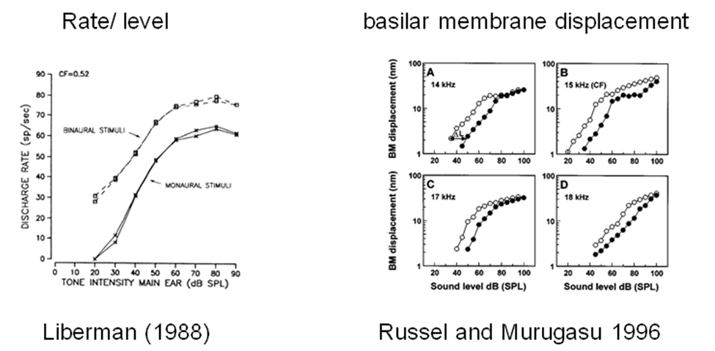

Figure 13. Examples of MAC measurements. Left: Spike rate of MOC efferent fibers (Liberman, 1988). Right: Depression of BM response following electrical stimulation of the MOC bundle.

There is only one level 2 unit in each channel and its firing rate is the sole basis for computing the MOC efferent activity in the corresponding channel. The spiking activity is smoothed using a lowpass filter with a time constant of 25 ms (cutoff 6 Hz) to create a value r(HSR)_{t}, and then adjusted using a scalar (currently 0.0063) to generate a gain factor, MOC_{t}

DRNLParams.MOCtau =.025;
DRNLParams.rateToAttenuationFactor = .00635;

MOC_{t} = 1 – rateToAttenuationFactor . r(HSR)_{t}

This is applied to the BM displacement for the corresponding BF channel in the nonlinear path only.

Evaluation
The response of the MOC can be visualized using test_MAP1_14 when it is set up to respond to a pure tone stimulus

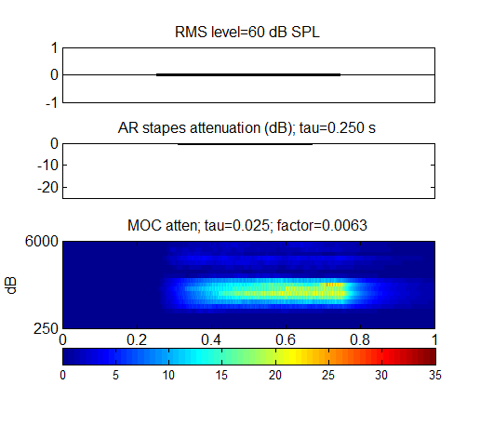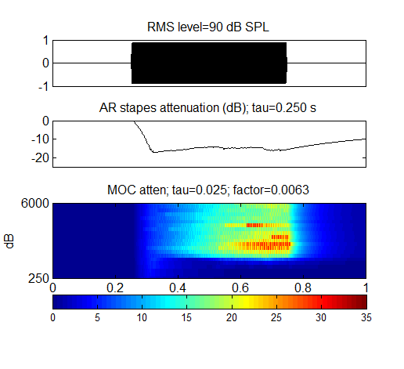
Figure 14. AR and MOC attenuation for a multi-channel model. Top panel:60-dB SPL, 1-kHz pure tone. Bottom panel: 90-dB SPL 1-kHz pure tone.

A check on the appropriateness of the MOC time constant can be made using the program LiebermanMOCtest in the MAP1_14\testPrograms folder

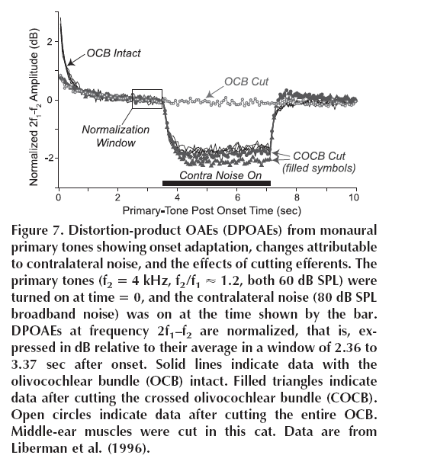 | 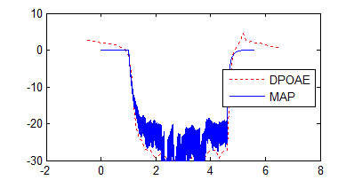
Figure 15. MOC attenuation fitted to Lieberman (1988) DPOAE data as a time constant check.

Acoustic reflex using the probability model
The probability model is a fast method for evaluating MAP but it lacks the necessary brainstem activity representation necessary to control the efferent pathways. As a work around we can use the AN firing rates for HSR and LSR fibers to act as a proxy. From many points of view, the approximation works well and is certainly good enough for the purposes of exploratory studies.

The implementation works by analogy, substituting the HSR mean rate across all channels as the control signal for the acoustic reflex. A different gain value is required of course

OMEParams.rateToAttenuationFactorProb=0.02;

The same applies to the MOC. However, a new parameter is required to discount the high spontaneous rate of the HSR AN fibers

DRNLParams.rateToAttenuationFactorProb = 0.0075;
DRNLParams.MOCrateThresholdProb =50;

The MOCrateThresholdProb parameter is subtracted from the HSR within-channel rate before the attenuation factor is applied.

Another complication (and a defect of this method) is that a much longer (and artificial) time constant is required to compensate for the rapid adaptation of the AN firing rate. However, for most purposes, this works well.

DRNLParams.MOCtauProb =.285;

Detection of a sound stimulus
A stimulus is deemed to have been detected if any one of the IC units produces at least one action potential during or very soon after the stimulus.

